# Get Team Names with CTEs (Final Version)

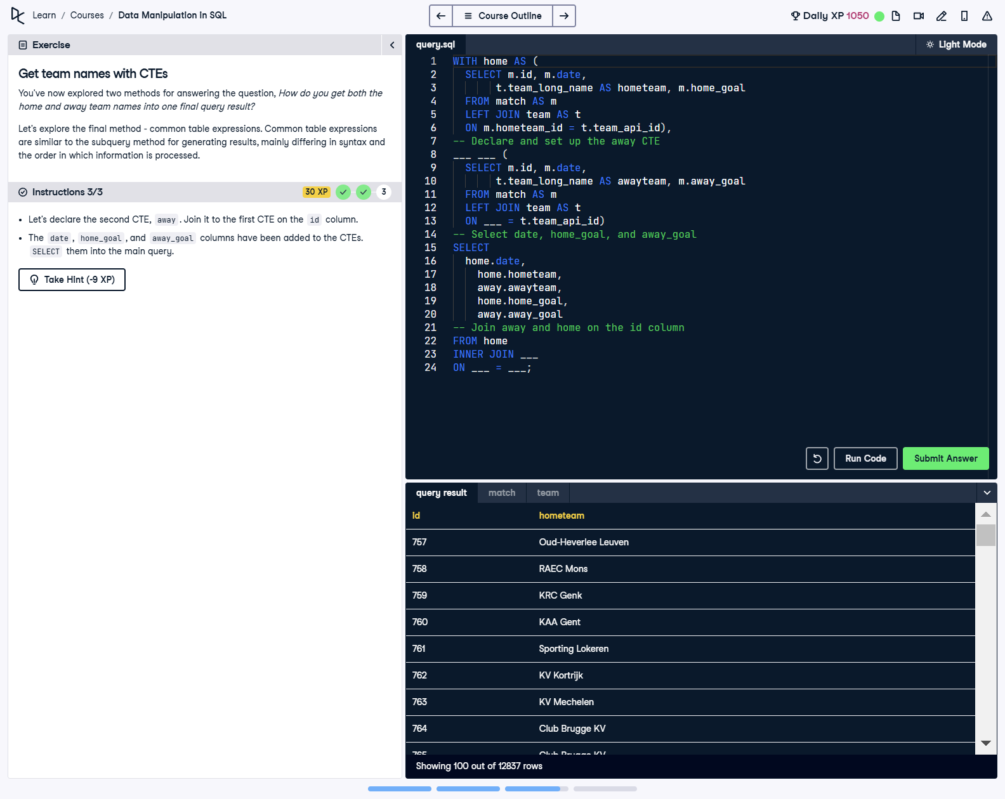

## Question

1. Let’s declare the second CTE, away. Join it to the first CTE on the id column.  
  
2. The date, home_goal, and away_goal columns have been added to the CTEs. Select them into the main query.

## Corrected Solution

WITH home AS (  
 -- Define the home CTE  
 SELECT   
 m.id,   
 m.date,   
 t.team_long_name AS hometeam,   
 m.home_goal  
 FROM match AS m  
 LEFT JOIN team AS t  
 ON m.hometeam_id = t.team_api_id  
),  
away AS (  
 -- Define the away CTE  
 SELECT   
 m.id,   
 m.date,   
 t.team_long_name AS awayteam,   
 m.away_goal  
 FROM match AS m  
 LEFT JOIN team AS t  
 ON m.awayteam_id = t.team_api_id  
)  
-- Select date, home and away teams, and their goals  
SELECT   
 home.date,  
 home.hometeam,  
 away.awayteam,  
 home.home_goal,  
 away.away_goal  
FROM home  
-- Join away and home CTEs on the id column  
INNER JOIN away  
ON home.id = away.id;

## Explanation

This query organizes data into two Common Table Expressions (CTEs), 'home' and 'away'. The 'home' CTE retrieves details about the home team, while the 'away' CTE retrieves details about the away team. These CTEs are joined together using the match ID (id) to produce a comprehensive output that includes match date, home and away team names, and their respective goals. This modular approach enhances readability and simplifies query maintenance.